Homework 3: Dynamically resizing an array of char pointers
Specification:
In this assignment, as you’ll read a number of string inputs from keyboard, you’ll keep on dynamically resizing an array of char pointers. Lastly, you’ll sort all the string inputs. I’ll talk about the sortString function in the class.
In the attached test file StringArrangement_test.c, 's' is a pointer to a char pointer, initially 's' is allocated storage for one char pointer.
char** s= malloc(sizeof(char*));
But ‘s’ will be able to grow dynamically to an unlimited size as the user keeps on typing a number of strings from the keyboard until the EOF (Ctrl +D ) is reached.
At first, you need to complete the following three steps inside the for loop:
for (count = 0; fgets(buff, sizeof(buff), stdin); count++){
- Step 1: allocate sufficient storage for s[count] to store the content in buff plus one byte for '\0';

- Step 2: copy the contents of 'buff' to 's[count]'
- Step 3: resize the array of pointers pointed to by 's' to increase its size for the next pointer;

}
As EOF is reached, you’ll be able to know the number of strings read from ‘count’.

Step 4: Next, you have to sort the string inputs You need to implement the sortString function. sortString takes as argument an array of pointers to char and the number of strings read, i.e., count.

Step 5: Print the list of sorted names. You can write a function for this. 2 pts
Step 6: Free the allocated memory. 3 pts
After you implement all the steps, you’ll see the following output for a number of names typed by the user:
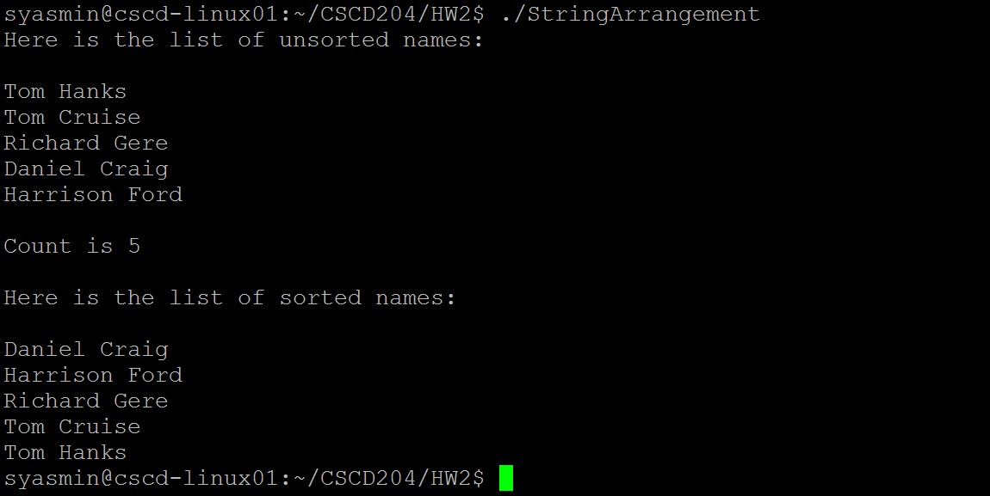
Submission:
A zip file containing:
- Your C code named StringArrangementHW3.c
- Output capture named StringArrangementHW3out.pdf – containing at least 3 different runs.
Name your zip file with your last name first letter of your first name HW3.zip (ex: YasminSHW3.zip)

Submission deadline is: 11:59 pm, Monday, February 25. No late submission will be considered.

